**SC531 – Lecture #02**

Consider this example of everyday logic:

Given:

All men are mortal. [1]

Ramesh is a man.

We deduce:

Ramesh is a mortal.

This is perfectly valid logic, but propositional logic does not provide for such a deductive step. Ramesh is an instance of man.

[Incidentally, how do we know that “All men are mortal”?]

In *predicate logic*, we write [1] as: For all *x*, *man*(*x*) 🡪 *mortal*(*x*) [2]

Here *x* is a *variable*; *man*() and *mortal*() are *predicates*.

Recall that the simplest sentence structure in English grammar is “*subject* *predicate*”. An assertion such as [2] may be TRUE or FALSE.

Here “Ramesh” is a *constant*. The full deduction step is written as:

Given:

For all *x*, *man*(*x*) 🡪 *mortal*(*x*)

*man*(Ramesh)

We deduce:

*mortal*(Ramesh) Note the instantiation.

Predicate logic is also known as *first order logic*.

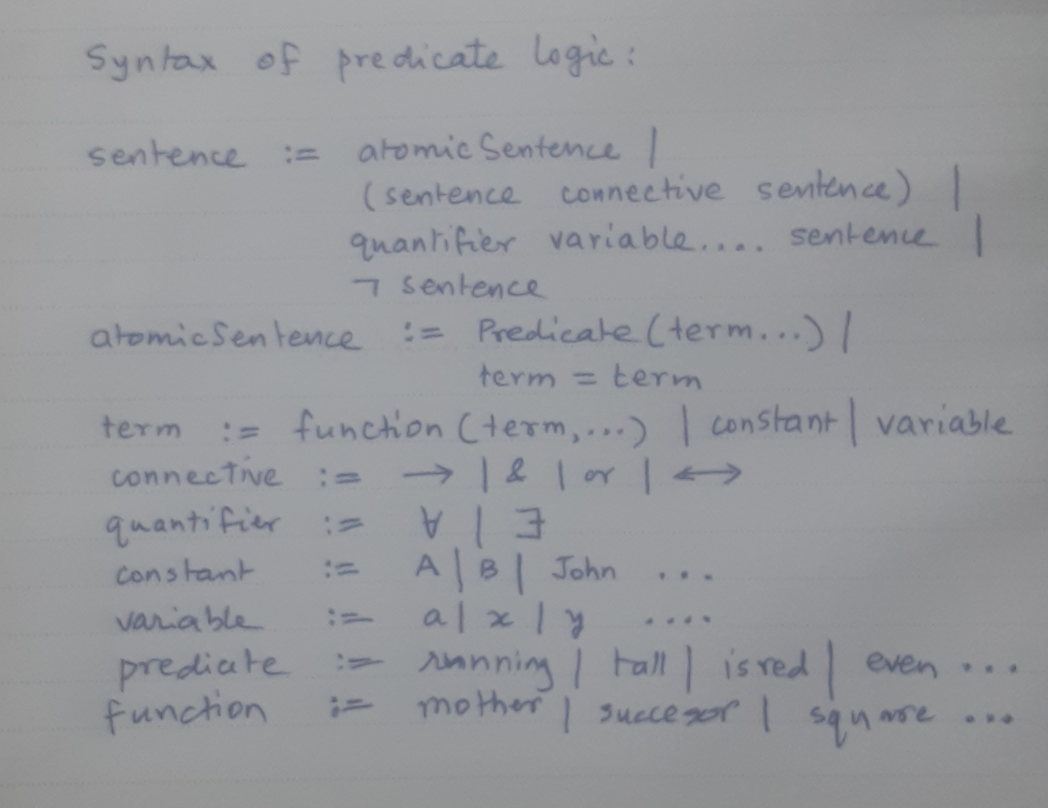

The two quantifiers are known as *universal quantifier* and *existential quantifier* respectively.

Quantifiers can be nested, such as in this trivial example:

For all *x*, there exists *y* such that (*y* > *x*)

There needs to be an implicit *universal set* to which the quantifier applies. In the previous trivial example, *x* and *y* are real numbers.

Programming language PROLOG provides a platform for logic programming.

Important note: Any system of formal logic need not have any correlation or points of agreement with the real world. The example shown above, for example, *does not and cannot prove* that in the real world there is a man named “Ramesh"!

Question:

What if someone writes:

Given:

For all *x*, *man*(*x*) 🡪 *immortal*(*x*)

*man*(Ramesh)

We deduce:

*immortal*(Ramesh)

There is nothing wrong with this logic -- except that it does not agree with reality!

***

Let us now switch to *reasoning in the presence of uncertainty*.

*Random experiment*: Although all possible *outcomes* of an experiment are known, the outcome of any particular *trial* cannot be predicted.

Why? We assume that there many unknown factors affecting the outcome. This is very often the situation in real life.

Examples: Rolling a die, rolling a pair of dice, tossing a coin, counting the number of customer arrivals at a bank per hour .....

Let S represent a *domain of values of interest*, and let A, B ... be any *propositions* or *predicates* over S. S is known as *sample space*.

Then the *probabilities* of A, B *et cetera* being TRUE are denoted by P(A), P(B) *et cetera*, which are real numbers satisfying the following axioms.

Axioms of probability:

a. 0 < P(A) < 1

b. P(TRUE) = 1, P(FALSE) = 0

c. P(A or B) = P(A) + P(B) – P(A & B)

This set of axioms is known as **Kolmogorov's axioms**.

Examples of sample space:

a. When we toss a coin: S1 = { head, tail }

b. When we throw a pair of dice: S2 = { 2, 3, .... 12 }

c. When we measure a travel time: S3 = [MIN ... MAX]

Note that S may represent a *discrete* or a *continuous* set of values.

Above, S1 and S2 represent discrete values, while S3 represents a range of continuous values.

Another example:

A coin is tossed four times in succession. What is the sample space of possible outcomes?

S4 = { HHHH, HHHT, HHTH, ..... TTTT }, with |S4| = 16.

[Note that we have NOT yet said anything about the coin being *unbiased*; that is, whether P(H) = P(T).]

How many of the above outcomes have equal number of heads and tails?

This can only happen when #(H) = #(T) = 2.



The answer is 4C2 = 6. Why?



By the same logic:

#(H) = 4 can happen in only ONE way.

#(H) = 3 can happen in FOUR ways.

#(H) = 2 can happen in SIX ways.

#(H) = 1 can happen in FOUR ways.

#(H) = 0 can happen in only ONE way.

Note that the sample space of “number of heads" is S5 = {0,1,2,3,4}.

Recall that:

(a+b)n

= (a+b) x (a+b) x ... x (a+b)

= nC0an + nC1 an-1b + nC2 an-2b2 + ..... + nCnbn Binomial expansion.

Suppose a biased coin with P(H) = 0.9 is tossed four times.

What is the probability of getting N heads, N = 4,3,2,1,0?

(i) 0.94 = 0.6561

(ii) 4 x 0.93 x 0.1 = 0.2916

(iii) 6 x 0.81 x 0.01 = 0.0486

(iv) 4 x 0.9 x 0.001 = 0.0036

(v) 0.14 = 0.0001

Note that these numbers add up to 1.0, because (0.9+0.1)4 = 1.